

*East West University*

#### Department of Computer Science and Engineering (CSE) Semester: (Spring, Year: 2025), B.Sc. in CSE

**Departmental Network Infrastructure for East West University using Cisco Packet Tracer**

#### Course Title: Computer Network

#### Course Code: CSE405

#### Section: 05

### Students Details

|  |  |
| --- | --- |
| **Name** | **ID** |
| Nishat Lubna | 2020-2-60-053 |
| Sheikh Sarafat Hossain | 2022-3-60-109 |
| Rijia Parveen Raya | 2022-3-60-192 |

#### Submission Date: 13 May 2025

#### Course Teacher’s Name: Rabea Khatun

**Signature:**

**Date:**

**Marks:**

**Comments:**

**Lab Project Status**

**Contents**

1. Introduction 2
   1. Overview
   2. Motivation
   3. Objectives
2. Design/Development/Implementation of the Project 3
   1. Project Details
   2. Development of the project
      1. IP Configuration
      2. FTP Server Setup
      3. Email Server Setup
      4. Router Configuration
      5. Network Topology
3. Result and Discussion 10
   * 1. System Functionality and Testing
4. Conclusion 11

**Chapter 1 Introduction**

# Overview

This project is based on creating a complete university network system using Cisco Packet Tracer. The main focus is to design a well-structured and secure network for East West University where all departments are connected through their own local area networks (LANs). Each department can communicate with others and access shared services like FTP and Email. The network uses dynamic routing for easier and automatic route sharing between routers. The purpose of the project is to simulate a real-life networking scenario that supports communication, file sharing, and internet services inside a university campus. Our goal is to create a working network model that is secure, well-organized, and easy to manage.

# Motivation

The main motivation behind this project is to help us understand how a large network works in real life. Universities need good network systems so that students, teachers, and staff can work smoothly. By doing this project, we get to practice everything we learned in class using Cisco Packet Tracer. It also prepares us for future jobs where we may need to design or manage real networks.

# Design Goals/Objectives

The main goals of this project are to design a network for East West University using Cisco Packet Tracer and create separate LANs for each department (CSE, EEE, Business, Law, Civil, Pharmacy, English, Genetic Engineering, and Admin) , assign different IP subnets to each department to keep the network organized.

* Set up one Email Server so that all departments can send and receive emails.
* Set up one FTP Server:
  + Full access for Chairman and Admin PCs (upload, download, rename, delete).
  + Limited access for other users (view and download only).
* Use routing (static or dynamic) to allow communication between departments.
* Ensure that all devices can ping each other and work properly.
* Add a basic web server for university notices or department information.

**2. Development of the Project:**

**2.1 Project Details**

The overall setup includes:

* **36 PCs** (PC0 to PC35) for different departments.
* **13 Routers** to connect all departmental networks.
* **3 Servers**:
  + FTP Server
  + Email Server
  + DNS Server

Each department has a switch to connect devices. We used 4 PCs where one is for the Chairman and all PCs are connected to the department switch. All departments are connected to a central router system for inter-department communication.

Network Addressing for each department is given below:

| **Department** |  | **Network Address** |
| --- | --- | --- |
| CSE |  | 192.168.10.0 |
| EEE |  | 192.168.11.0 |
| Business |  | 192.168.12.0 |
| Law |  | 192.168.13.0 |
| Civil |  | 192.168.14.0 |
| Pharmacy |  | 192.168.15.0 |
| English |  | 192.168.16.0 |
| Genetic Engineering |  | 192.168.17.0 |
| Admin |  | 192.168.18.0 |

**2.2 Implementation**

**2.2.1 IP Configuration**

We used dynamic IP addressing for all devices. Each department was given a unique IP subnet. The Chairman PC of each department got the first IP, while other PCs got the next IPs.

for Example:

Pharmacy Department:

* Chairman PC0: 192.168.15.1
* PC1: 192.168.15.2
* PC2: 192.168. 15.3
* PC3: 192.168.15.4

All PCs were assigned default gateways (e.g., 192.168.15.5 for Pharmacy) to allow communication outside their LAN.

**2.2.2 FTP Server Setup:**

One central FTP Server was added. Chairman PCs and Admin PCs got full permissions (read, write, delete, rename, list).Other department PCs got limited permissions (download and view list only).Access control was set using FTP user roles. Username and Passwords were set.

**2.2.3 Email Server Setup :**

* A central Email Server was set up.
* All PCs were configured with email clients.

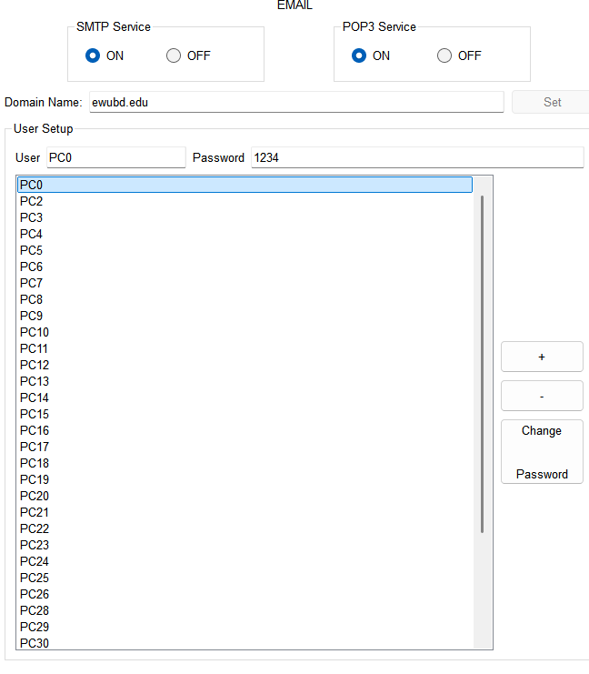

* Each PC could send and receive emails using the server
* A screenshot of a computer

  AI-generated content may be incorrect.Test emails were exchanged between departments to confirm successful setup.

**2.2.4 Routing Configuration :**

Dynamic Routing was implemented using RIP (Routing Information Protocol) where each router was configured with RIP to automatically exchange route information. Commands like router rip and network statements were used. After configuration, routers could dynamically learn all available routes. End-to-end communication across the university was successful.

**2.2.5 Web Server Setup:**

We have also set up a WebServer within the network. The web server was hosted on the same machine as the DNS Server to save resources and make the network setup more efficient. The web server was configured to serve a basic HTML homepage showing university information and announcements. The DNS Server is updated with an entry (**www.ewubd.edu or ewubd.edu or ewu**) that pointed to the domain of the web server.

All devices in the network could access the website by typing the domain name in a browser.

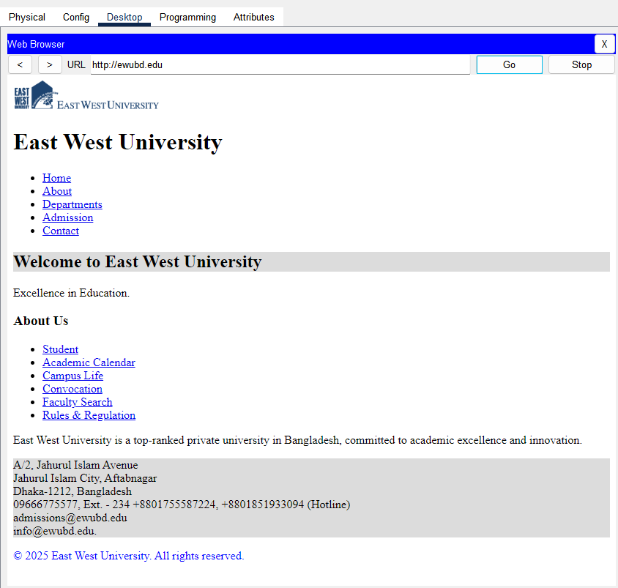

This showed that the DNS service and web hosting were working together properly. It added real-world functionality and simulated how institutions host their own internal websites.

**2.2.4 Network Topology**

The final design is shown below. It includes all departments, routers, switches, servers, and connections:

**3. Result and Discussion**

**3.1.1** **System Functionality and Testing**

We successfully built the network as per the given plan. After full implementation, the following results were achieved:

* Each department is on its own subnet and can communicate internally.
* Dynamic routing allowed automatic communication between all networks.
* FTP access worked as planned:
  + Full access for Chairmen and Admin PCs: Chairmen/Admin can view, upload, delete, rename files.
  + Limited access for general users: Others can only download/view.
* The email system is working. PCs can send and receive emails across all departments.
* Ping tests were done to check connectivity, and all devices responded successfully.
* IP addressing is clean and easy to manage.
* The internal website hosted on the DNS Server was also tested.
* All PCs in different departments can access the web page using the domain name via DNS.
* This shows that both web hosting and DNS resolution were functioning correctly.

We tested the system using Cisco Packet Tracer’s simulation mode. All services (FTP, email, ping) worked without issues. The network can be expanded easily in the future.

**4. Conclusion**

This project allowed us to design, implement, and test a complete departmental network for East West University using Cisco Packet Tracer. Through this simulation, we created a structured network that supports multiple services such as FTP, email, web hosting, and inter-department communication. Each department was given its own subnet, ensuring proper organization and scalability.

We successfully applied **dynamic routing (RIP)** to automatically share routing information across 13 routers, which reduced manual configuration and made the network more flexible. Additionally, access controls on the FTP server were correctly configured to provide different permission levels for Chairmen, Admins, and regular users. The Email Server worked well, enabling smooth communication among all departments, and the DNS Server successfully supported name resolution for the internally hosted web page.

One of the most valuable parts of this project was the opportunity to apply theoretical networking knowledge to a practical simulation. We faced minor challenges during configuration and routing setup, but overcoming them helped strengthen our troubleshooting and problem-solving skills.

Overall, this project gave us hands-on experience with real-world networking components, improved our understanding of network design, and prepared us for future work in the field of computer networking and IT system administration.